1. Design TM using simulator to perform string comparison where w={aba aba}

INPUT:

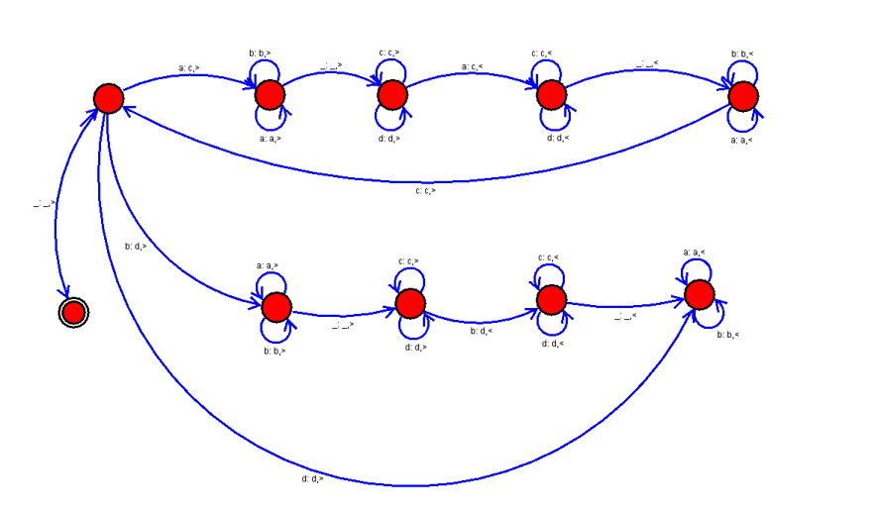

OUTPUT:

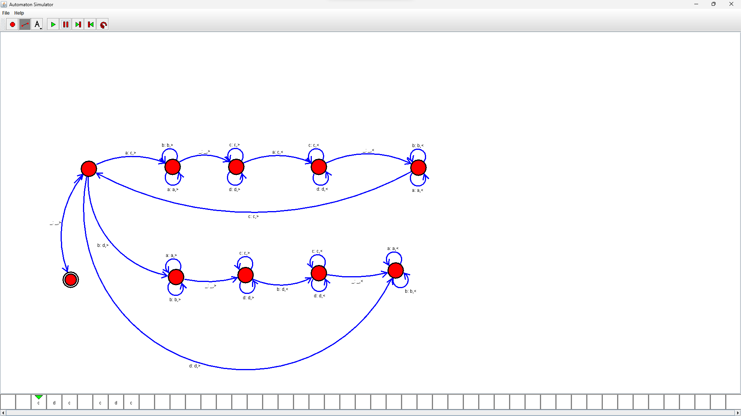

RESULTS:

We designed TM using simulator to perform string comparison by using autosim